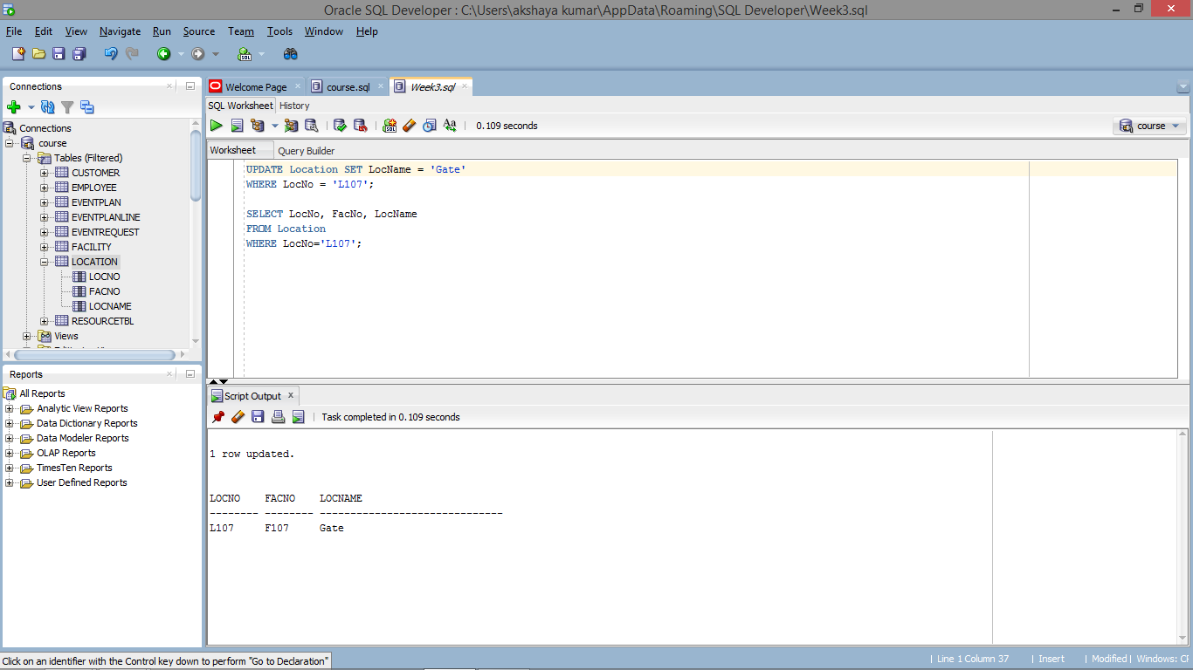

UPDATE Location SET LocName = 'Gate'

WHERE LocNo = 'L107';

SELECT LocNo, FacNo, LocName

FROM Location

WHERE LocNo='L107';